INSK Weblogic 安裝手冊

1. 設定環境變數

export MW_HOME=/export/home/insksit/Oracle/Middleware/

export MW_HOME=/export/home/inskuser/Oracle/Middleware/

export WLS_HOME=$MW_HOME/wlserver_12.2.1.4

export WL_HOME=$WLS_HOME

export JAVA_HOME=/usr/jdk/jdk1.8.0_271/

2. 修改response.rsp

ORACLE_HOME=/export/home/insksit/Oracle/Middleware/wlserver_12.2.1.4/Oracle_Home

ORACLE_HOME=/export/home/inskuser/Oracle/Middleware/wlserver_12.2.1.4/Oracle_Home

3. 修改oraInst.loc

inventory_loc=/export/home/insksit/Oracle/Middleware/wlserver_12.2.1.4/inventory

inventory_loc=/export/home/inskuser/Oracle/Middleware/wlserver_12.2.1.4/inventory

4. 將下列檔案放到$HOME/weblogic/

fmw_12.2.1.4.0_wls.jar

oraInst.loc

response.rsp



5. 執行安裝 (參數要絕對路徑)

$JAVA_HOME/bin/java -d64 -jar fmw_12.2.1.4.0_wls.jar -silent -responseFile /export/home/insksit/weblogic/response.rsp -invPtrLoc /export/home/insksit/weblogic/oraInst.loc

/usr/jdk/jdk1.8.0_271/bin/java -d64 -jar fmw_12.2.1.4.0_wls.jar -silent -responseFile /export/home/inskuser/Change_tmp/response.rsp -invPtrLoc /export/home/inskuser/Change_tmp/oraInst.loc

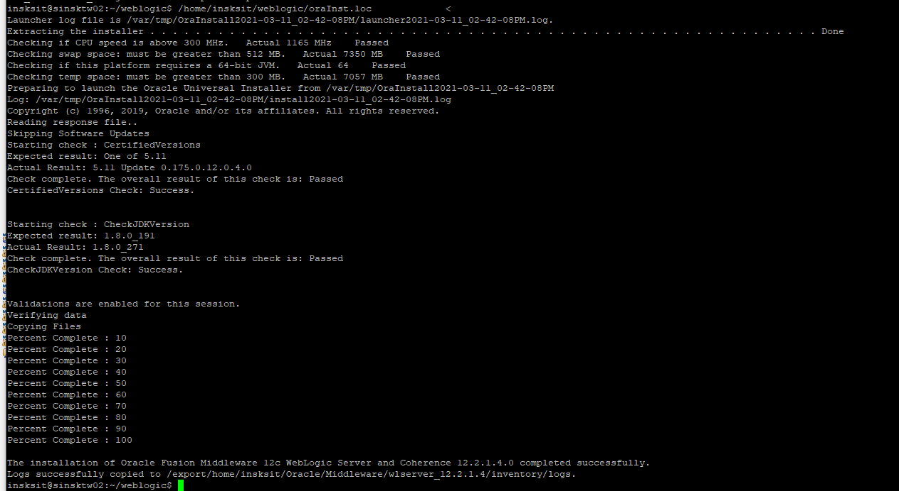

6. 安裝domain – 建立domain路徑

mkdir /export/home/insksit/wls_domains/insk_domain_12_2_1_4_0

mkdir /export/home/inskuser/wls_domains/insk_domain_12_2_1_4_0

7. 安裝domain – 複製安裝domain設定檔到Domain安裝路徑

cp /export/home/insksit/Oracle/Middleware/wlserver_12.2.1.4/Oracle_Home/wlserver/common/templates/scripts/wlst/basicWLSDomain.py /export/home/insksit/wls_domains/insk_domain_12_2_1_4_0/

cp /export/home/inskuser/Oracle/Middleware/wlserver_12.2.1.4/Oracle_Home/wlserver/common/templates/scripts/wlst/basicWLSDomain.py /export/home/inskuser/wls_domains/insk_domain_12_2_1_4_0/

cp /export/home/inskuser/Oracle/Middleware/wlserver_12.2.1.4/Oracle_Home/wlserver/common/templates/scripts/wlst/basicWLSDomain.py /export/home/inskuser/wls_domains/insk_domain/

8. 安裝domain – 修改domain設定檔(basicWLSDomain.py) (左: before / 右:after)

修改port

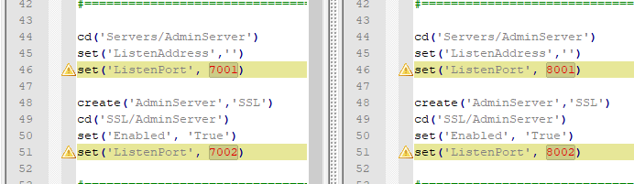

新增預設weblogic密碼及AdminServerName(帳號: weblogic/ AdmSvr_INSK)



設定domain dir



# 9. 安裝domain

cd /export/home/insksit/wls_domains/insk_domain_12_2_1_4_0

cd /export/home/inskuser/wls_domains/insk_domain_12_2_1_4_0

/export/home/insksit/Oracle/Middleware/wlserver_12.2.1.4/Oracle_Home/wlserver/common/bin/wlst.sh basicWLSDomain.py .

/export/home/inskuser/Oracle/Middleware/wlserver_12.2.1.4/Oracle_Home/wlserver/common/bin/wlst.sh basicWLSDomain.py .

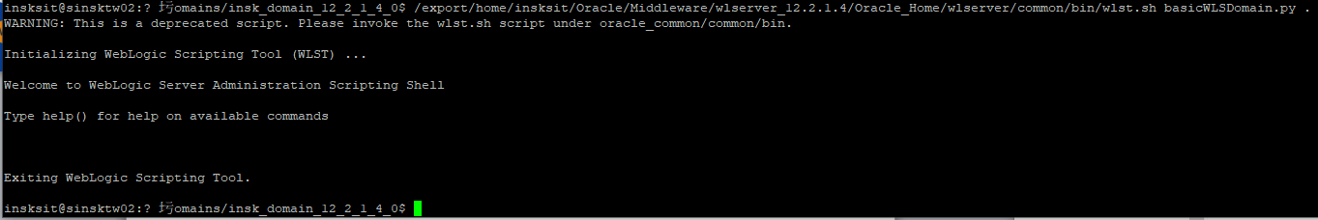

10. 修改weblogic啟動設定/export/home/insksit/wls_domains/insk_domain_12_2_1_4_0/bin/setDomainEnv.sh

/export/home/inskuser/wls_domains/insk_domain_12_2_1_4_0/bin/setDomainEnv.sh

Weblogic使用的JAVA_HOME (SUN_JAVA_HOME)

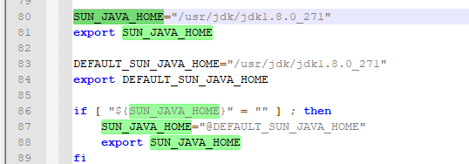

啟動Weblogic時的JAVA參數 – 可用記憶體空間(WLS_MEM_ARGS_64BIT)

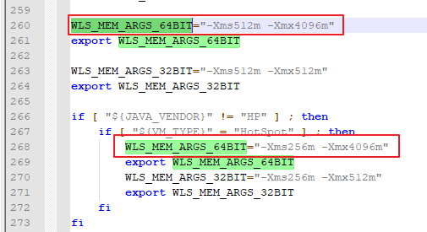

11. 修改設定檔/export/home/insksit/Oracle/Middleware/wlserver_12.2.1.4/Oracle_Home/oracle_common/common/bin/commBaseEnv.sh使weblogic以64位元執行

/export/home/inskuser/Oracle/Middleware/wlserver_12.2.1.4/Oracle_Home/oracle_common/common/bin/commBaseEnv.sh使weblogic以64位元執行

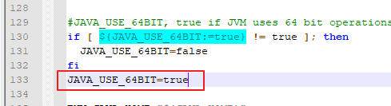

12. 啟動weblogic Admin Server

cd /export/home/insksit/wls_domains/insk_domain_12_2_1_4_0/bin

cd /export/home/inskuser/wls_domains/insk_domain/bin

修改startWebLogic.sh參數順序(將serverName前移)

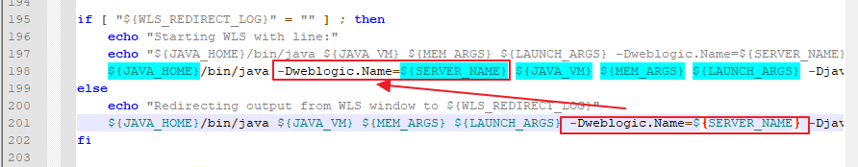

nohup sh startWebLogic.sh >/export/home/insksit/app/logs/weblogic/AdmSvr_INSK.stdout 2>&1 &

# start admin

nohup sh startWebLogic.sh >/export/home/inskuser/app/logs/weblogic/AP/AdmSvr_INSK.stdout 2>&1 &

13. 登入後設定weblogic

(帳號: weblogic 密碼: 詳basicWLSDomain.py中cmo.setPassword('sitadmin138')設定)

建立ManagerServer

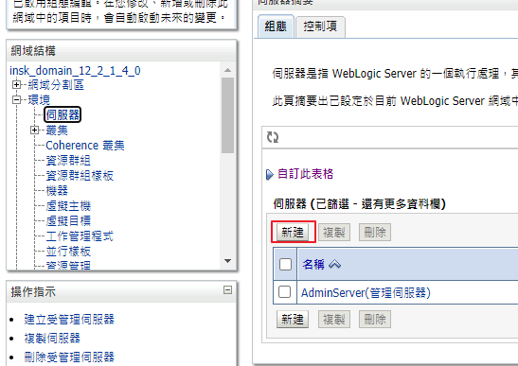

MngSvr_INSK

8003

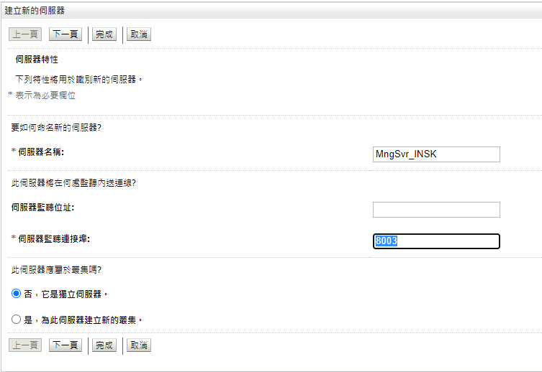

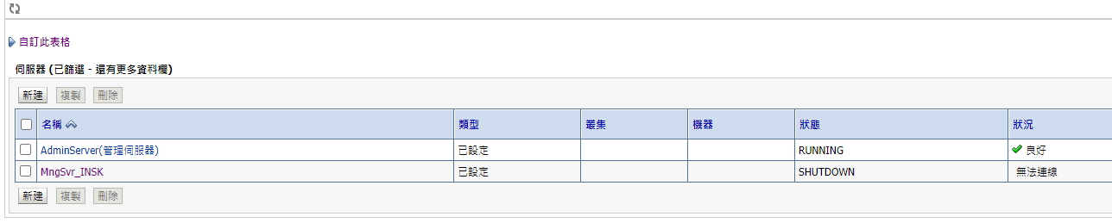

刪除預設DataSource

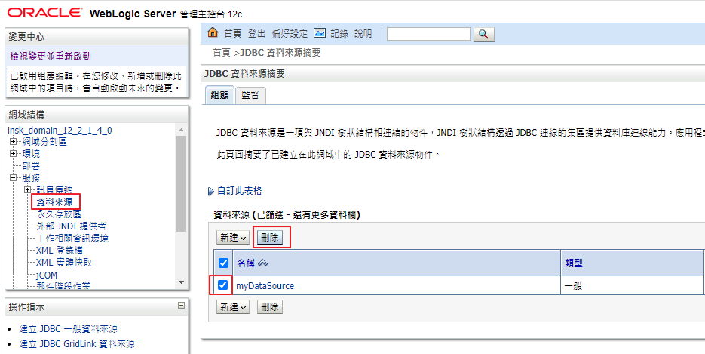

新增DataSource (沒貼畫面直接下一步)

inskDataSource

jdbc/inskDataSource

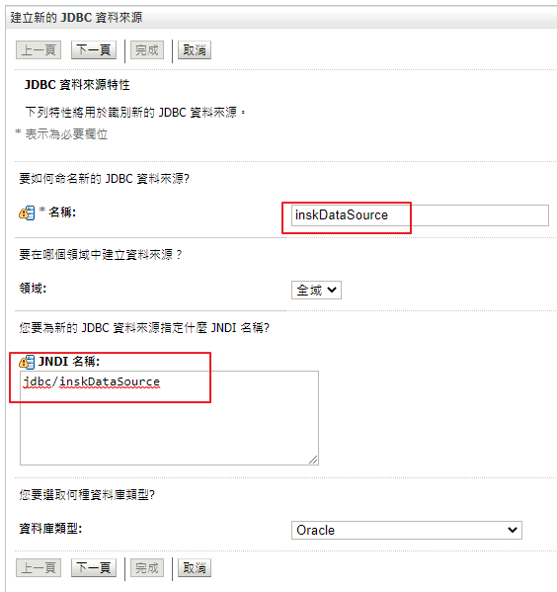

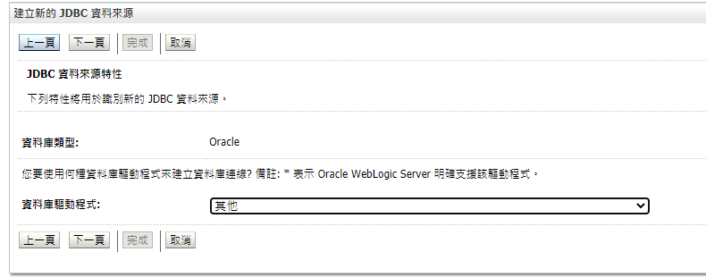

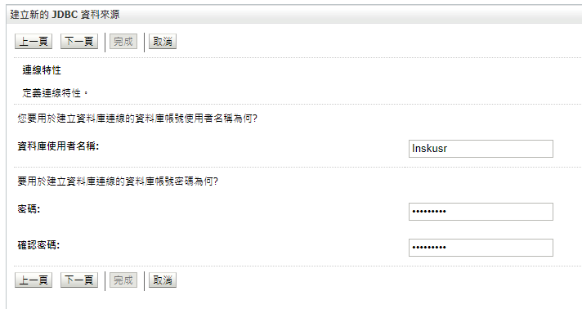

oracle.jdbc.xa.client.OracleXADataSource

jdbc:oracle:thin:@//172.24.37.196:1803/inskt19c

prod   
url:

jdbc:oracle:thin:@(DESCRIPTION=(ADDRESS_LIST=(load_balance=on)(ADDRESS=(PROTOCOL=TCP)(HOST=dburl1)(PORT=1803))(ADDRESS=(PROTOCOL=TCP)(HOST=dburl2)(PORT=1803)))(CONNECT_DATA=(SERVICE_NAME=inskp)))

驅動程式類別名稱:

oracle.jdbc.xa.client.OracleXADataSource

特性:

user=inskusr

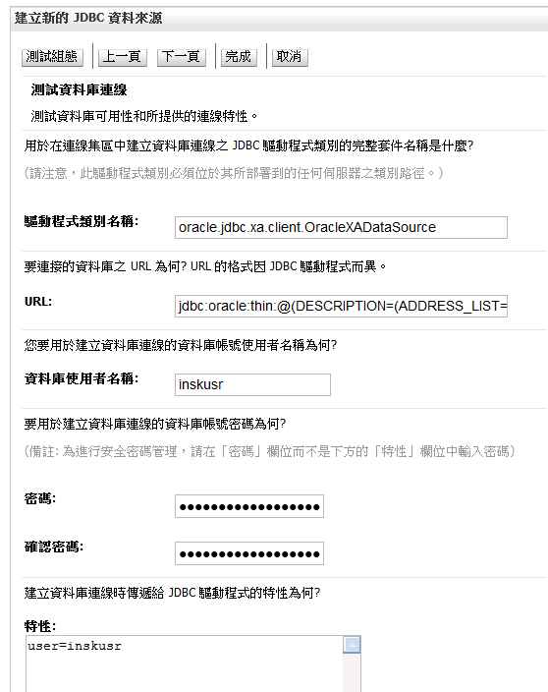

若有在/etc/hosts新增” 172.24.37.196 sinskdb-scan.chinatrust.com.tw”即可使用domain

(root權限)

jdbc:oracle:thin:@sinskdb-scan.chinatrust.com.tw:1803:inskt19c

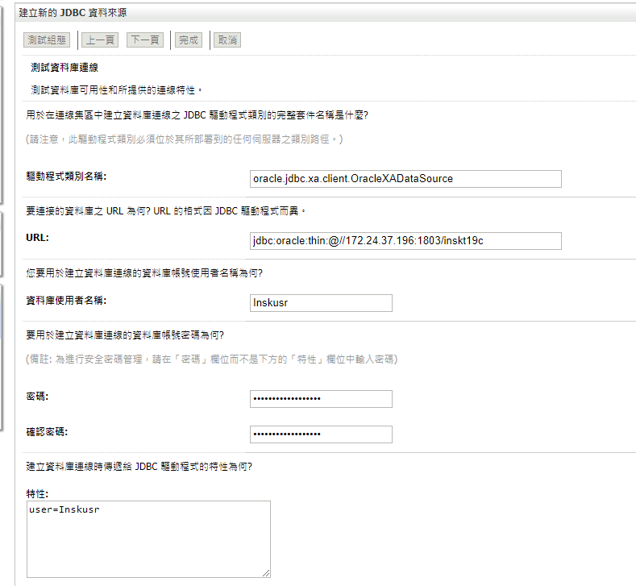

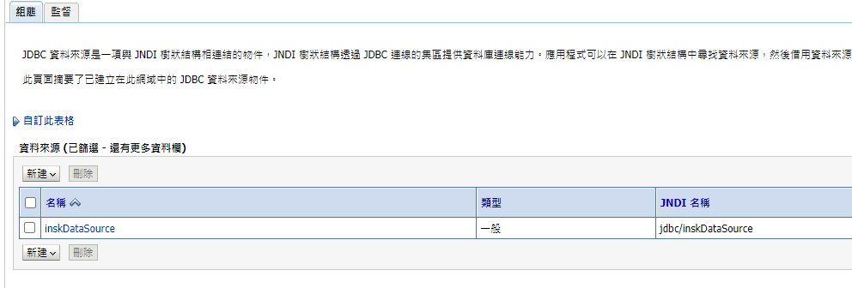

設定target -> 點進datasource

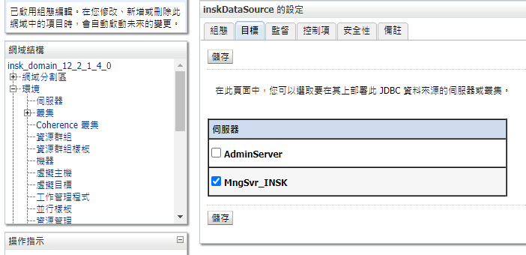

建立新使用者sitadmin

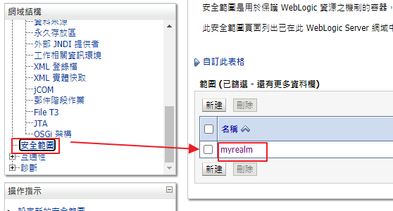

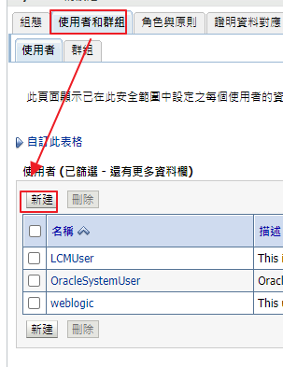

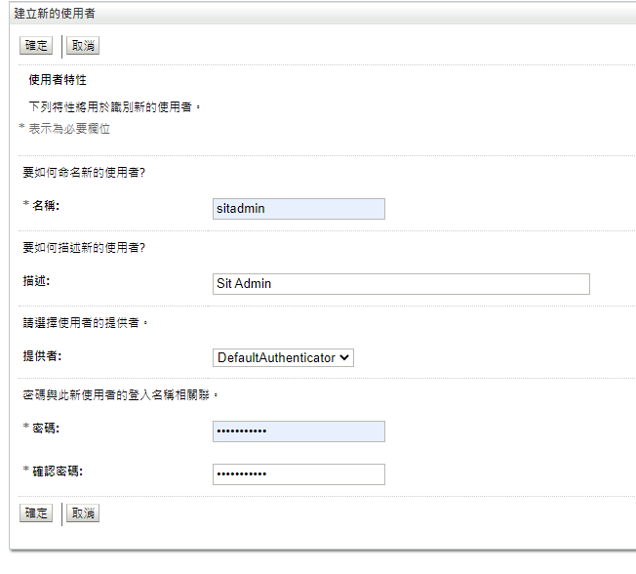

新增完成

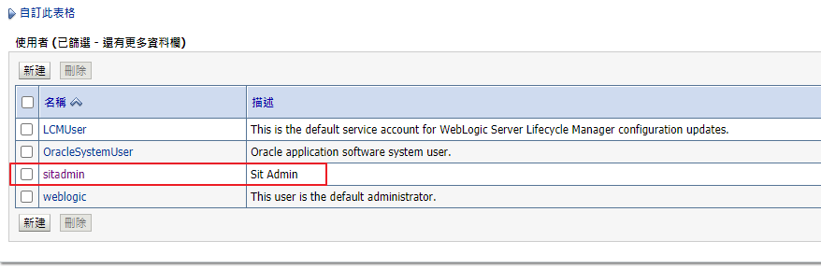

點進去新增權限

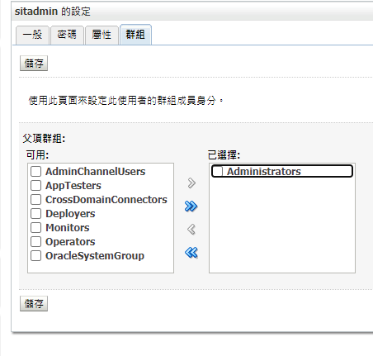

14. 啟動ManagerServer(因為沒設定啟動帳號密碼，要手動輸入)

cd /export/home/insksit/wls_domains/insk_domain_12_2_1_4_0/bin

sh startManagedWebLogic.sh MngSvr_INSK <http://127.0.0.1:8001>

cd /export/home/insksit/wls_domains/insk_domain/bin

sh startManagedWebLogic.sh MngSvr_INSK <http://127.0.0.1:7001>

15. 複製啟動AdminServer帳號properties至ManagerServer

cp -rf /export/home/insksit/wls_domains/insk_domain_12_2_1_4_0/servers/AdminServer/security /export/home/insksit/wls_domains/insk_domain_12_2_1_4_0/servers/MngSvr_INSK

cp -rf /export/home/inskuser/wls_domains/insk_domain/servers/AdminServer/security /export/home/inskuser/wls_domains/insk_domain/servers/MngSvr_INSK

16. 修改adminServer的ServerName

# 停掉AdminServer及ManagerServer

/export/home/insksit/Oracle/Middleware/wlserver_12.2.1.4/Oracle_Home/wlserver/common/bin/wlst.sh

/export/home/inskuser/Oracle/Middleware/wlserver_12.2.1.4/Oracle_Home/wlserver/common/bin/wlst.sh

啟動成功後，依序執行以下指令

readDomain('/export/home/insksit/wls_domains/insk_domain_12_2_1_4_0')

readDomain('/export/home/inskuser/wls_domains/insk_domain')

cd ('/Servers')

ls()

cd ('AdminServer')

cmo.setName('AdmSvr_INSK')

updateDomain()

exit()

異動AdminServer目錄

cd /export/home/insksit/wls_domains/insk_domain_12_2_1_4_0/servers

cp -rf AdminServer AdmSvr_INSK

(待確認修改完成可自行移除AdminServer)

修改啟動AdminServer ServerName

/export/home/insksit/wls_domains/insk_domain_12_2_1_4_0/bin/setDomainEnv.sh的SERVER_NAME=” AdmSvr_INSK”

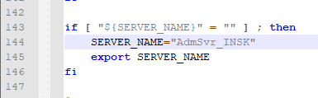

啟動AdminServer及ManagerServer

將scripts解壓後搬到home(需視環境調整setENV.ksh內參數及ManageWebLogic.ksh內setENV.ksh路徑)



以chmod 777 *開啟scripts中執行權限

以menu.ksh啟動AdminServer及ManagerServer

17. 安裝程式(沒截圖就是[下一步]或[完成])

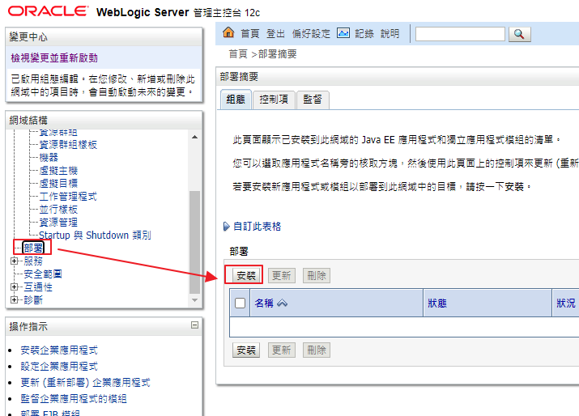

安裝2個sys_lib

/export/home/insksit/insk-make/ec-sys-lib

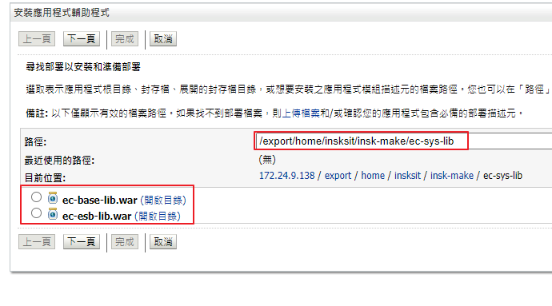

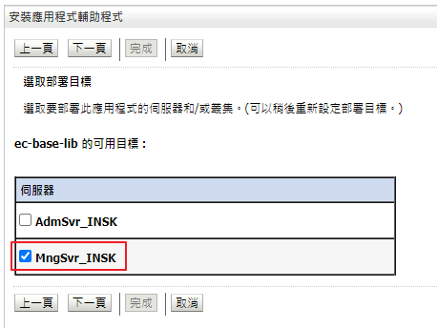

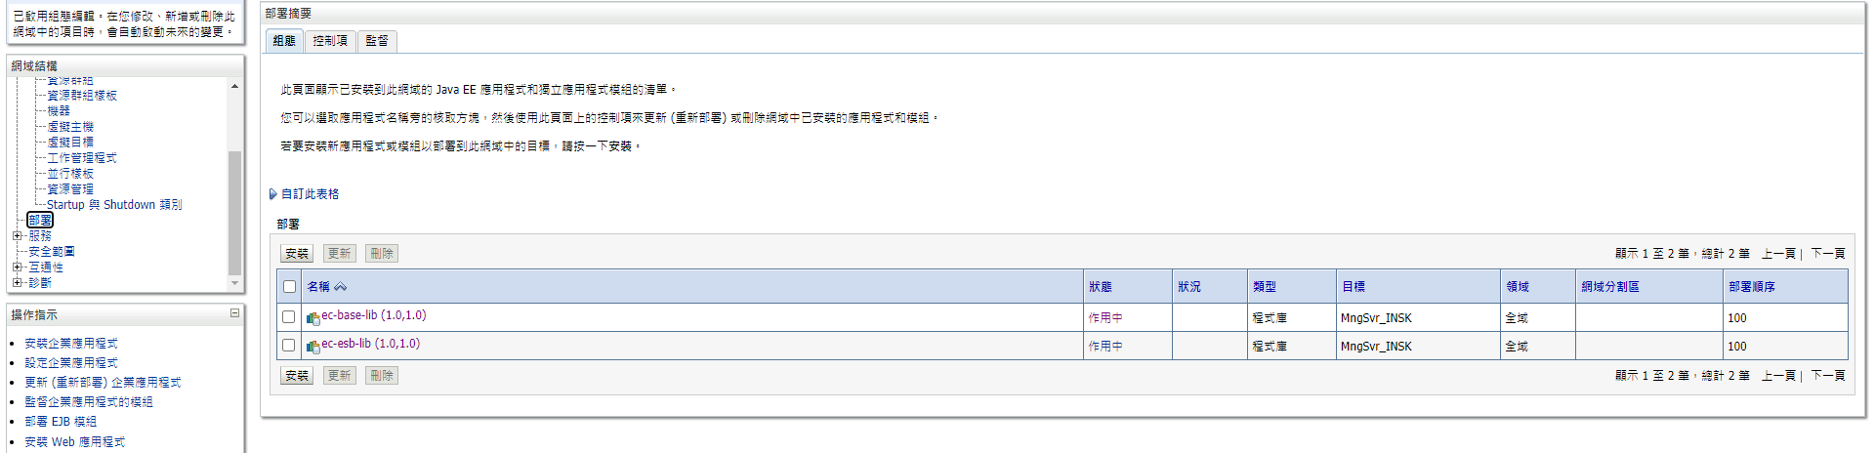

在安裝這6個

/export/home/insksit/insk-make/ec-user-lib

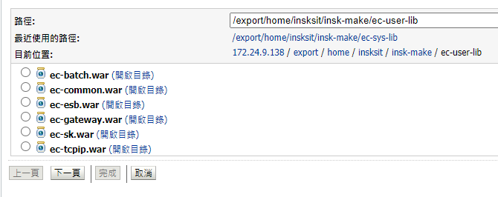

最後安裝這3個

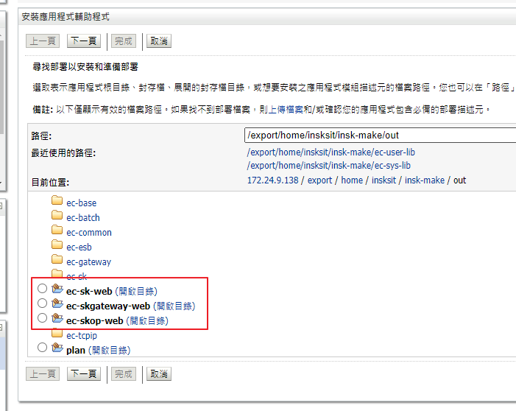

部屬完成

